Talal Abu Ghazaleh University to Open in September

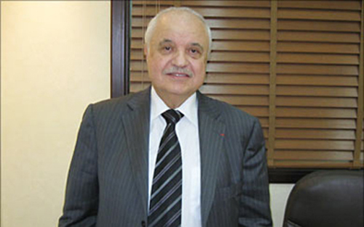

PM - 09/04/2012- Manama, April 9 (BNA) -- Chairman of Talal Abu Ghazaleh Group stated that teaching at the new Talal Abu Ghazaleh University for Business Studies, in Sanabis, will start next September.

He confirmed readiness of the state-of-the-art university to introduce e-learning in the knowledge-based society.

Abu Ghazaleh explained, in an exclusive interview with BNA during his current visit to the Kingdom as a keynote speaker at the Bahrain International eGovernment Forum, that the university will teach an elite of outstanding students with the same methods used at Talal Abu Ghazaleh Graduate School of Business in Jordan. These methods are based on studying cases and practical practice, far from the traditional lecturing method.

On the cost of establishing the university, Abu Ghazaleh said "we are talking here of many millions spent in Bahrain, which shows our confidence and firm faith in the Bahraini market and the value of our investment in this country. Talal Abu Ghazaleh Group will continue to harness all our capabilities to provide all professional services and quality management consulting for all government departments as well as civil society and educational institutions in the Kingdom."

He also commented on Bahrain ranking first among Arab countries and twenty-seventh in the world according to the Networked Readiness Index in a report issued by the Global Information Technology, in cooperation with the "INSEAD", at the World Economic Forum.

He described the rating as "a great achievement worthy of appreciation", one that wouldn’t have been if not for the wise vision of His Majesty King Hamad bin Isa Al Khalifa, His Royal Highness Prime Minister Prince Khalifa bin Salman Al Khalifa and His royal Highness Prince Salman bin Hamad Al Khalifa, the Crown Prince.

He also lauded the care given by Shaikh Mohammed bin Mubarak Al Khalifa, Deputy Premier and Chairman of the Supreme Committee for Information and Communication Technology, to the eGovernment Project.

Mr. Abu Ghazaleh went on saying "it is clear from the results that this great effort made by the wise leadership of Bahrain on all levels was the reason behind these achievements which are the pride of all the GCC and Arab people." "I am proud of Bahrain's achievements in the fields of business practices and advanced eGovernment," he asserted.

Concerning his participation in the Bahrain International eGovernment Forum this year, Mr. Abu Ghazaleh said "I am here as the keynote speaker at the forum and will speak of the eGovernment's goals in serving citizens, there is a lot of uncertainty which the Forum seeks to clarify. The main goal of the eGovernment is to provide better services for citizens by easier and cheaper means."

He added that he will focus his speech on the point that there is no electronic government without electronic populations, and that the culture of electronic knowledge should be generalised through training programmes and providing opportunities of e-learning for all citizens in order to reach the slogan "Every Citizen is Digital".

On the latest inventions of Talal Abu Ghazaleh Group, he revealed that the group will establish before the end of the year its own "Computing Cloud" to include all its services, to be the first of its kind on the private service companies level in the region, pointing out that "Abu Ghazaleh Cloud" will provide terms of information exchange and transparency, protection and confidentiality at the same time.

TAGorg is considered the biggest Arabic group for professional services in the areas of accountancy, management consultancy, training, intellectual property, legal services, information technology, capacity building and translation. Moreover, the group is registered with the World Bank, the Register of Accountants and Auditors (Washington), and the UN Center for Transnational Corporations (New York).

The group holds over one thousand and five-hundred professionals in multiple specialties, working from over seventy offices and a hundred-and-eighty representative offices in the MENA region, with representative offices in Europe and Northern America.

http://www.bna.bh/portal/en/news/502973

